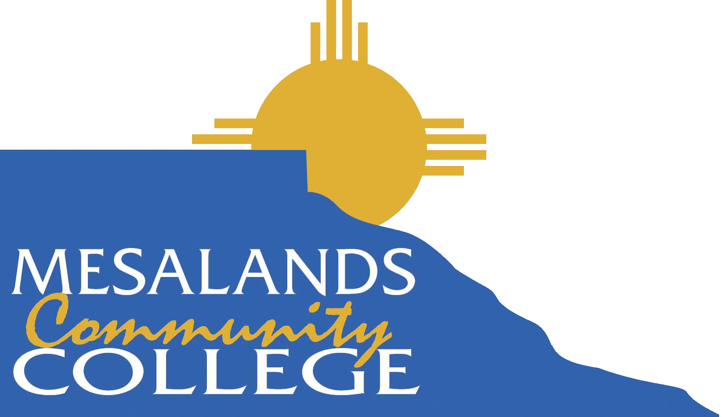

**LIABILITY WAIVER AND RELEASE FORM (MINOR CHILD)**

***THIS IS A RELEASE OF LEGAL RIGHTS — READ AND UNDERSTAND BEFORE SIGNING***

I hereby certify that I am the adult parent or guardian of , a minor child under the age of eighteen years, and I consent to his/her participation in recreational activities at Mesalands Community College located at 911 South Tenth Street in Tucumcari, New Mexico. I also allow my children to access the internet in the camp classes that require computer/internet access.

I understand and acknowledge that I am fully aware of and assume the risks (including but not limited to the risk of serious bodily injury, property loss or damage) of (1) said minor child’s participation in recreational activities at the Mesalands Community College and (2) his/her participation in Summer Adventure Camp. I recognize my responsibility to ensure that said minor child participates only in those activities for which he/she has the required skills, qualifications, training and physical conditioning. I understand that Mesalands Community College or its staff/ employees shall have no responsibility to pay for medical treatment and related costs if said minor child is injured.

Knowing the risks described above, I agree, personally and on behalf of the minor child named above, to assume all the risks and responsibilities surrounding my minor child’s participation in Summer Adventure Camp. To the fullest extent allowed by law, I hold harmless and agree to indemnify Mesalands Community College, its officers, directors, faculty, staff, volunteers, employees and agents, from and against any present or future claim, cause of action, loss or liability for injury to person or property, which said minor child may suffer or for which said minor child may be liable to any other person, related to said minor child’s participation in recreational activities at Mesalands Community College resulting from any cause whatsoever, and regardless of fault.

I am at least eighteen years of age and have carefully read and freely signed this Liability Waiver and Release Form (Minor Child). I understand and agree that no oral or written representations can or will alter the contents of this document. I agree that this agreement shall be governed by the laws of New Mexico (excluding its conflict of laws principles).

**Name:**

**Signed: Date:**